Active Kent & Medway Board Recruitment Pack

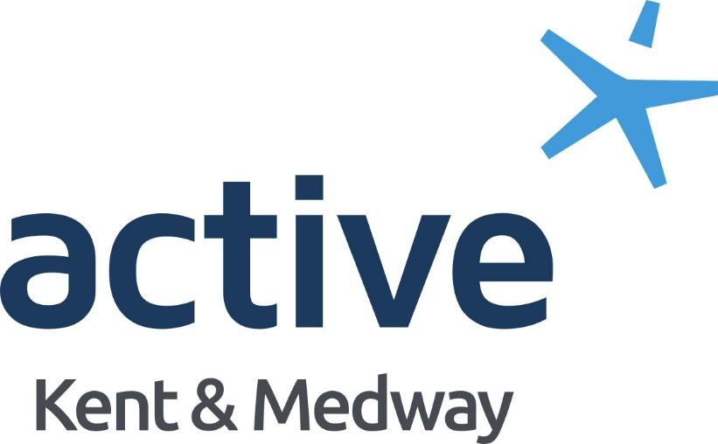

Welcome note from Active Kent & Medway Chair
Dear potential Board Member,
Active Kent & Medway exists to change lives through sport and physical activity. This drives everything we do and motivates every single person engaged with our organisation. We lead, support and connect people and partners across our county through our shared vision of More People, More Active, More Often. Uniting communities and creating more equal and inclusive places so that people can lead happier, healthier and more fulfilled lives.
We can only achieve this by surrounding ourselves with outstanding individuals as we go on our journey. This is where you come in.
We recognise and embrace the benefits of having a balance of skills and experiences on our Board, and see increasing diversity and inclusivity at Board level as an essential element to achieving our stated aims and objectives. As an organisation, we believe we should be reflective of the people within our communities and as such we are looking to strengthen our already talented and committed Board. At this moment in time, we are particularly interested in those with a background and experience in finance, governance or health, and currently have three vacancies we are looking to recruit to.
This pack is designed to provide you with the information you will need to make an informed decision about working with Active Kent & Medway and clarity on the expectations of the role. I am more than happy to answer any questions you may have and would encourage you to get involved, even if it is your first Board position.

Graham Razey OBE
Active Kent & Medway
Board Chair

About Us
Active Kent & Medway (formerly Kent Sport) is one of 43 Active Partnerships in England. Our principal funders are Sport England and Kent County Council, whose strategies and outcomes set the direction of our work and activity.
Our vision is ‘more people, more active, more often’.
Our mission is to ‘change and improve lives through sport and physical activity’.
To achieve this, we aim to increase participation in sport and physical activity with a focus on encouraging the least active of Kent’s 1.8 million residents to become more active. Through the promotion of associated personal and public health benefits, we will target resources where need is greatest, especially at those from under-represented groups, including women, older people, people living with a disability or long-term health condition, ethnically diverse communities, and people from lower socio-economic groups.
We engage with partners and networks across Kent and Medway – including those in health, adult social care, community safety, housing, and transport, as well as governing bodies of sport, clubs, school sports networks and local authorities, to provide opportunities for everyone to get involved in sport and physical activity for enjoyment as well as wider health and social outcomes.
Active Kent & Medway is an unincorporated partnership and is directed and guided by an independent board which sets the strategy, oversees, scrutinises and guides the work of the staff team, making decisions where appropriate. It is responsible for the provision of good governance and overseeing delivery of Move Together – The Sport and Physical Activity Strategy for Kent and Medway 2023 - 27.
The Strategy focuses on the following key themes:
- Connecting Communities: Bringing communities together and harnessing sport and physical activity’s unique ability to make places better to live;
- Positive Experiences for Children and Young People: Helping children and young people to enjoy being active and creating the right foundations for a long, active and healthy life;
- Supporting Sport: Supporting local organisations to better understand their community and to deliver activities appropriate to people’s needs and motivations;
- Connecting with Health and Wellbeing: Working in partnership and enabling everyone to benefit physically and mentally from an active lifestyle;
- Active Environments: Creating and protecting the places and spaces that make it easier for people to be active.
The Active Kent & Medway staff team helps coordinate this work through an annual Operating Plan, which focuses on ensuring that:
- Organisations who work with those who are less active, are embedding sport and physical activity into their services.
- The sport and physical activity sector is inclusive and accessible, and better able to meet the needs of our communities.
- New audiences are reached by prioritising resources to tackle inequalities.
Active Kent & Medway is also responsible for the delivery of Everyday Active – a countywide campaign to promote physical activity and encourage the least active to move more in their everyday lives.

Our Board
Graham Razey OBE
Board Chairman since July 2022.
Graham is the Chief Executive of EKC Group, a family of six colleges and four business units that deliver a wealth of technical, vocational and academic education across the whole of east Kent.
Natalie Curtis
Welfare & Safety Champion and Equalities Champion - Joined in July 2015.
Natalie is currently the Head of Academy at London City Lionesses.
Adam Lawrence
Audit and Governance Committee Chair - Joined in April 2017.
Adam is a Director of Sports Connect, an education-focused organisation, which uses the power of sport to inspire, motivate and educate. He was also formerly the CEO of Gillingham Football Club Community Trust.
John Taylor
Senior Independent Member, and Nominations Committee Chair - Joined in April 2016.
John played rugby for Wales from 1967 to 1973 – during their golden era – and made two Lions Tours playing in all four tests in the historic 1971 series victory over the All Blacks.
Liu Batchelor
Board Member since Dec 2021.
Liu is a video and communications expert working with Kent SMEs and charities. She is also a TV presenter, having hosted an active travel show airing on Sky.
Gurvinder Sandher
Board Member since Dec 2021.
Gurvinder is the Artistic Director of Cohesion Plus and CEO of the KECC. He has worked in the voluntary sector in Kent since 1999 and established Cohesion Plus in 2008 to complement his work around equality and diversity.
Karen West
Board Member since Dec 2021.
Karen lives in Kent and has over 25 years experience at a senior level in sport, leisure health, regeneration, and project management.
Tom Marchant (Ex-Officio Member)
Head of Strategic Planning and Policy at Kent County Council and the Host Agency Representative on the Board

The Board's Key Role

- Leadership – provide effective leadership to AKM, the staff team and key stakeholder
- Governance – ensure compliance with governing document, best practice and other relevant legislation to protect the values, reputation and integrity of AKM.
- Strategy – set the strategic direction of AKM
- Financial – Take financial responsibility to safeguard the assets and continuity of AKM. Agree priorities for funding and investment as well as assessing and managing risk, compliance and reporting.
- Delivery and impact – Provide scrutiny and constructive challenge with regard to delivery plans, policies, progress and impact
- Advocacy and Influence – Champion and advocate the work of AKM, engaging with and influencing key decision makers
- Partnership – Ensure strategic relationships and alliances are developed at high levels through effective partnership engagement and transparent communication.

Board members may also be asked to support priority areas of Active Kent & Medway’s work and to engage with specific committees or working groups, e,g, Nominations Committee, Audit and Governance Committee, Board Safety and Welfare Champion, AKM Diversity and Inclusion Group.

Opportunity to join the Board
Active Kent & Medway is seeking to appoint two new Board Members. We are particularly interested in recruiting individuals with an understanding, skills and/or experience in one or more of the following areas:
- Financial Management
- Health Sector
When applying we ask you to state your interest in either of these positions.
New Board Members should also be able to demonstrate:
- An understanding of the work of the Active Partnership and share our passion for the power of sport and physical activity to improve lives, and be committed to tackling the inequalities so intrinsically linked to inactivity, and to equality and diversity more broadly
- Good independent judgement
- An ability to think creatively
- A willingness to provide constructive challenge
- An understanding and acceptance of the legal duties, responsibilities and liabilities of Board membership
- An ability to work effectively as part of a team
- A commitment to work to Nolan’s seven principles of public life: selflessness, integrity, objectivity, accountability, openness, honesty and leadership
- Charity business specific expertise and experiences e.g. HR, finance, marketing, business development, legal etc.

Further information
Commitment
- 4 x main Board meetings per year (2 days).
- 1 x Board Away Day (1 day).
- Both our Sub Committees (Nominations and Audit & Governance) meet biannually as a minimum. You may be asked to sit on one of these (1 day).
- Undertake a Board Induction training session (0.5 day).
- 1 x annual performance review with the Chair of the Board (0.2 day).
- In addition, Board Members may contribute to specific project/steering groups as they arise from time to time and will be invited to a number of optional events throughout the year.
Eligibility
Board Members should, preferably, either live or work within Kent and have an interest in helping people to be active to benefit their health and wellbeing within Kent (as defined by the Kent County Council and Medway Council area).
Board Members must be aged 18 or over and entitled to live and work in the United Kingdom.
Remuneration
This is a non-salaried appointment, travel and other reasonable expenses will be reimbursed.
Location
Board meetings and events will be held either online or at locations throughout Kent and Medway.
Term
Four years with the opportunity to be considered for reappointment for a second term of four years (Maximum of eight years).
Induction and Training
An induction programme will be offered to new Members and relevant training provided during the term of your appointment.

Privacy Notice
The information that you provide as part of your application will be used in the selection process only. All information about you will be securely held and access restricted to colleagues directly involved in dealing with the selection process. Active Kent & Medway is committed to being transparent about how it collects and uses data and to meeting its data protection obligations. Our full privacy policy is available here
By submitting your application, you are giving your consent to your personal data being stored and processed for the purposes of this Board selection process.
Equality Statement
Sport and physical activity is an intrinsic part of many local communities, which contributes to the quality of life of many people and fosters community cohesion. It also has the ability to bring people together and to develop teamwork and co-operative skills and can provide a wide range of opportunities for all sections of the community to participate and to enjoy the benefits to their health and wellbeing.
As a lead partnership agency and a provider of services for sport and physical activity, Active Kent & Medway and our Board are committed to promoting equality, valuing diversity, combating unfair treatment and proactively tackling inequalities in sport and physical activity.
We are committed to ensuring that current and potential service users, employees (including volunteer helpers), Board Members and applicants for roles either with Active Kent & Medway or our Board, will not be discriminated against on the grounds of social circumstances or background, gender, gender identity, ethnicity, disability, sexuality, age, religion, pregnancy & maternity or marriage & civil partnerships. The principles of tolerance and understanding and respect for others are central to what we believe. Active Kent & Medway and the Board are committed to progressing towards achieving gender parity and greater diversity generally on its Board, including, but not limited to disability and cultural diversity.

Recruitment process
Application is via the link below, where you will be asked to outline your skills and experience, upload your CV and complete a short equality monitoring questionnaire.
Applications should be submitted by completing this form - https://activekent.org/about-us/partnership-board/active-kent-medway-board-recruitment/
In the form, you will be asked to outline your reason for wanting to join the AKM Board, highlight your skills and experience as relevant to the vacancy you are looking to apply for (Finance, Governance or Health), and more broadly how you think you could contribute to AKM and our ambition to get more people, more active, more often across Kent and Medway.
Suitable applicants will be invited for an interview with the Chair, other Board Members, and the Active Partnership Director. Active Kent & Medway use diverse panels when considering any application.
Appointments will be made subject to ratification by Sport England and Kent County Council, receipt of satisfactory references and completion of declaration of interests and declaration of good character forms. References will only be taken up and declarations asked to be completed if an applicant is asked to join the Board.
All Board Members are expected to adhere to the Board Code of Conduct. This will be provided if an applicant is invited to become a Board Member.
KEY DATES
Closing date: Wednesday 20 December 2023
Interviews: w/c Monday 8 January 2024
Should you have any further questions, please do not hesitate to contact our Chair, Graham Razey, at Graham.Razey@eastkent.ac.uk or our Partnership Director, Liz Davidson, at Liz.Davidson@kent.gov.uk.

