Everyday Active Schools is designed to increase children’s physical activity levels by taking a whole school approach to embedding physical activity across the school day, focusing on seven areas of opportunity:

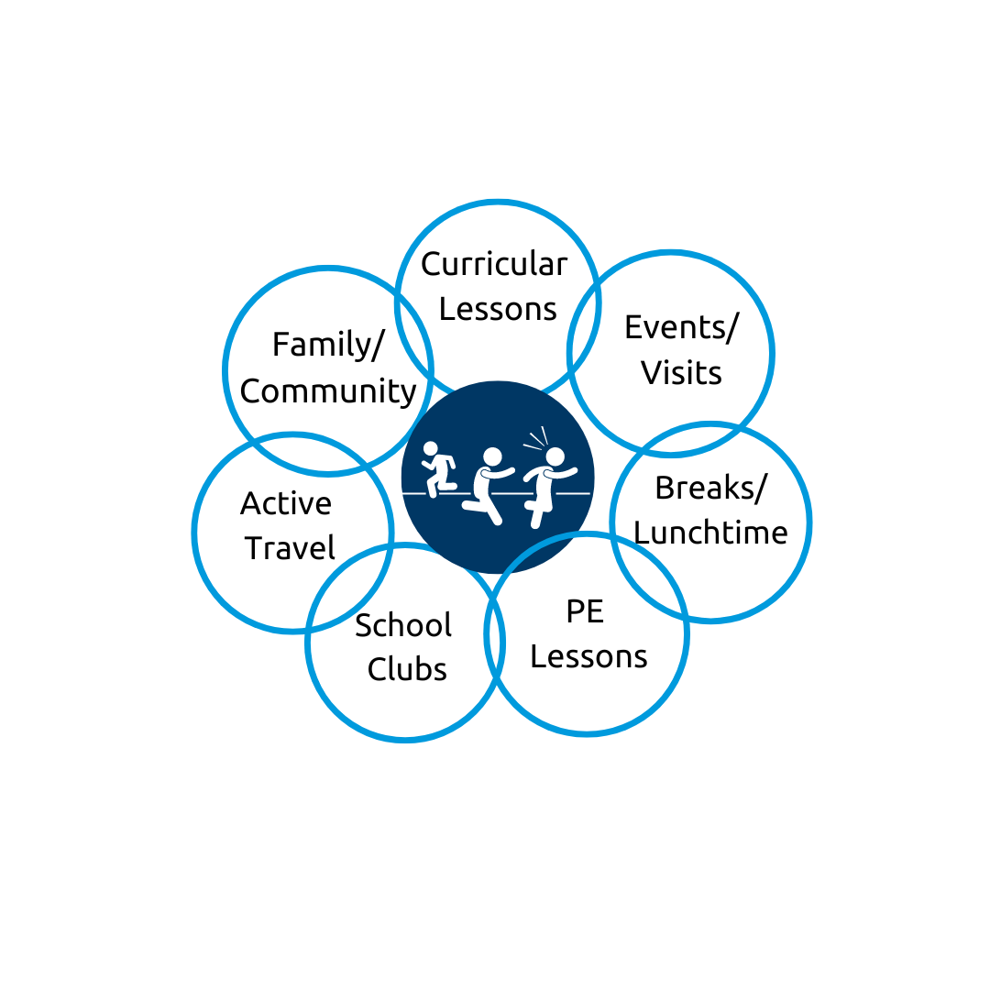

We’ve compiled a list of ideas for schools to implement within each of the 7 key areas of opportunity. This is not an exhaustive list and new ideas will be added throughout the academic year.

|  |  |  |
| --- | --- | --- |
| Events / Visits | | |
| Increase attendance in sporting events | Link up with your local secondary school to set up a PE transition event | Contact your local School Games Organiser to see what events are on in your area |
| Plan and go on a sensory walk | Class sleepover (include outside games) | Have a 'Healthy Week' (promote healthy eating and lifestyle choices) |
| Whole school sports day at a larger venue | Interhouse sporting competitions | Local walking visit (to the library, local sports centre, market etc) |
| Active council - run activity sessions for each class | Lets get active launch event | Set a staff challenge |
| Get an inspirational athlete in | Litter picking in the local community | Active sponsored challenge for each class |
|  |  |  |

|  |  |  |
| --- | --- | --- |
| Break / Lunchtimes | | |
| Play leaders at break and lunchtimes | Buy new play equipment solely for break / lunchtimes. Conduct a student survey to see what activities or equipment are wanted. | Consider adding an afternoon breaktime |
| Active lining up  Tiptoe/ animal walking in from break/lunch | Consider splitting playground into zones | 100 club (children complete 100 laps of the playground over a term) |
| Midday supervisors to run physical activity at lunch | Get balance bikes for EYFS and KS1 | Establish a girls football team and give them a dedicated day and space to practice |
| Playground active bags (resource card and equipment for pupils to set up their own physical activity) | Class spotted being most active throughout the week is rewarded with an extra break | MUGA (or equivalent) timetable (different year groups can utilise the space for activity) |
| Consider splitting playground into zones | 2 minute yoga calm down after break and lunch | CPD for MDSAs |
|  |  |  |

|  |  |  |
| --- | --- | --- |
| PE Lessons | | |
| Provide CPD for staff to deliver PE lessons | Active lining up in PE lessons whilst waiting for their turn | Perform an equipment audit |
| Have a PE lesson one a term where children try a new activity | Children to wear PE kit to schools on PE days | One PE lesson a week to be high intensity |
| Run/walk a mile or half in each lesson | PE Interventions | Incorporate new units into PE plan |
|  |  |  |

|  |  |  |
| --- | --- | --- |
| Curricular Lessons | | |
| Share active learning ideas in staff meetings | Create a working document of activities to integrate into lessons | Movement breaks in lessons |
| Keeping a class activity log | Active or stand up register (children stand up to answer their name). Register challenges (challenge after child has responded to name) | Cross curricular orienteering |
| Develop a school garden (each class responsible for a different area) | Yes/ no, true/false poster (children move to either side of the room to answer) | 2 hands up stretch for hands up |
| Take lessons outside when possible | Stop and drop activities throughout the day | Active travel to assembly (different activity each day). Active assemblies (e.g Lets dance Friday) |
| Add being an active school to your improvement plan (behaviour and wellbeing) | Change planning proforma to add opportunities for physical activity during lessons | Active certificate added into weekly celebration awards |
|  |  |  |

|  |  |  |
| --- | --- | --- |
| Before / After School | | |
| Consider introducing a new sports/ activities to your club offer. Targeted sports clubs based on children's interests | Increase physical activity at breakfast clubs (give children increased space for activities) | The Daily Mile |
| Morning yoga sessions | Conduct a review of the effectiveness of extra-curricular clubs | Consider a student survey to see what activities the least active want to engage in |
| Orienteering event for pupils and families | Open up clubs to more year groups | Have older pupils help with the delivery of clubs to the younger years |
| Forest school club afterschool | ‘Healthy Holidays’ (additional activity clubs during the holiday) | Community club (children walk around the community and think of actions for improvement) |
| Club aimed at least active/ SEN (e.g. sensory circuits) | Offer PE facilities/equipment in the morning | Ask the parents if they have any experience in delivering physical activity. ‘Try it’ club with a new activity each week |
|  |  |  |

|  |  |  |
| --- | --- | --- |
| Active Travel | | |
| Sign up to the Living Streets travel tracker | Create your own school system for tracking active travel to school | Scooter to school timetable (each class can have a turn using the scooter racks) |
| Sign up to Sustrans Big Walk and Wheel | Promote bike/ scooter racks | Walk to school assembly (promote benefits of active travel) |
| Give badges to those children actively travelling at least once a week | Encourage parents to park further away from the school and walk in | Whole school challenge to travel round the world |
| 'Walking Wednesdays' | 'Scoot into Friday' | Have a class monitor to record and keep track of active travel |
|  |  |  |

|  |  |  |
| --- | --- | --- |
| Family / Community | | |
| Set more active homework | Purchase Moki bands and have whole school competitions | Healthy selfie homework (pictures shared and celebrated) |
| Put on a parent/child fitness class on | Active monitors in each class to track activity/ implementation | Whole school achievement board for students and staff |
| Encourage sharing of pictures of being active on school social media pages | No phone/email Friday (staff have to walk around the school physically delivering messages) | Take part in an active fundraiser |
| Set physical activity challenges to do at home with families (e.g how many street signs can you count on a five minute walk) | Walking parents group | Forest school day (families invited to help) |
| Staff regularly share updates about activities in their lives to encourage children | Active shoutout on the weekly newsletter |  |
|  |  |  |